**UNIT 5 BUSINESS PERFORMANCE MANAGEMENT 9 Hrs.**

**Business performance management cycle - KPI, Dashboard - Analytics in Business Support Functions: Sales & Marketing Analytics - HR Analytics - Financial Analytics - Production and operations analytics- Analytics in Industries: Telecom, Retail, Healthcare, Financial Services - Decision Making under Uncertainty**

**Case study: prepare a detailed report on applications of analytics in different industries.**

**What is business performance management?**

Business performance management is a metric to determine overall business progress towards goals. Management teams assess individual employees and whole departments to make the right decisions about their company. It is important to note that this method is not limited to analyzing the financial aspects of a business, but also considers employee and customer satisfaction.

Business performance management is highly valuable because the company collects data about the business for quantitative information. For example, some data collected might include the number of sales made in a given month or the company's current cash flow. When a company uses business performance management, they collect and interpret data to assess their business operation holistically.

**Why is business performance management important?**

Business performance management is a beneficial way to evaluate employees and overall company behavior. A company that uses business performance management considers crucial data and goal progress in analysing how they are doing. There are many benefits to business performance management, including:

**Aligning with goals**

When a company uses business performance management, they consider how the company aligns with established goals. Goals are advantageous in a business because they act as a motivator and provides a concise objective for all employees to achieve.

When using business performance management, you directly assess your company's goals, how quickly they achieve milestones and what additional work they need to do towards completion. The management team establishes business goals for the whole company and tracks progress throughout the year using business performance management.

**Considering alternatives**

When using business performance management, the business considers alternative solutions to achieving its goals. Considering alternatives happens when the initial approach the business executed did not produce satisfying results. This is a benefit of business performance management because it invites new ideas and encourages innovative thinking among employees. Alternatives might even present a better approach because it considers additional data and the management team learns from previous experience.

**Keeping everyone accountable**

When a management team uses business performance management, they keep their employees accountable. Managers and supervisors assess employee performance and as a result, employees tend to consider company goals more frequently. When businesses hold employees accountable, employees recognize their responsibility.

When a company uses business performance management, its assessment of the company is more transparent. Employees are better aware of the company's evaluation methods and what their managers' expectations of them are.

**Three main activities of business performance management**

Business performance management uses three main activities that drive well-informed decision-making. Consider the three main activities of business performance management:

**Goal selection**

Goal selection is when the business decides on short- and long-term goals. Several members of a management team think of these goals. Goals are realistic and take into consideration the trajectory of the business. At times, the company might decide to focus on specific goals and chose to postpone others. This allows for dedicated time, energy and resources spent on a few selected goals instead of a broader focus on many goals.

**Information consolidation**

Information consolidation, also known as information monitoring, is the gathering of data on the business. This activity provides significant information for the management team to assess and guide decision-making. When a business uses information consolidation, they aim to provide accurate and reliable information for the team's reference. Information consolidation is constant, as new data about the company is continually created.

**Management intervention**

A management intervention, also known as a "managerial adjustment," is the action the management takes to improve business functioning. The business determines this decision by referring to data from information consolidation, considering the business mission and reviewing goals. For example, a supervisor might begin to check in with an employer weekly rather than on a bi-weekly basis.

**What is the performance management cycle**

The performance management cycle is a model that allows management and employees to better achieve organisational goals through a structured process of employee development.

The performance management cycle is a part of the performance management process or strategy, it is shorter and utilises a continuous four-step procedure of planning, monitoring, reviewing and rewarding.

Benefits of utilizing this method include increased competitiveness, more structural flexibility, and higher employee motivation.

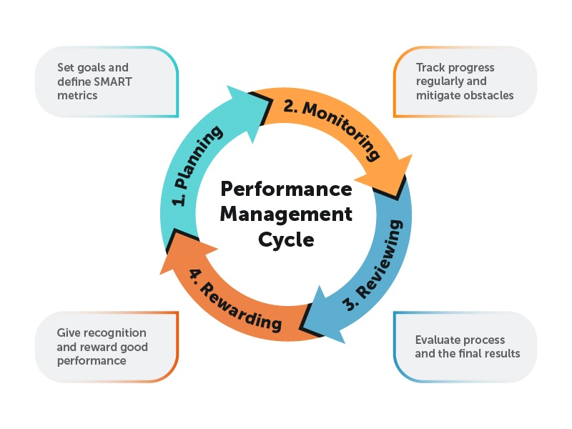

**Performance management cycle stages**

The performance management cycle definition encompasses four main stages:

* Planning
* Monitoring
* Reviewing
* Rewarding

The model traditionally runs on a year-long timeline, ending with a performance review, although various organisations have found that more frequent check-ins will improve employee performance.

One of the benefits of integrating a proper performance management cycle plan is an employee who is more aligned with the goals of the organization, who understands both their own objectives and the larger objectives of the organization and has a solid roadmap that will help them achieve their objectives.

Stages of the performance management cycle

Let’s take a closer look at each stage of the performance management cycle.

**1. Planning**

In the planning stage, the groundwork for success is laid down. Before management talks to the employee, the management team should meet and decide the organization’s goals and objectives for the year.

This involves the overall strategy for the business, but also the personal objectives for all employees and teams, including development goals, specific tasks, targets, actions and behaviors.

Without that crucial information, any planning with employees will not be effective.

Once the management team knows the details of what they want the employee to achieve, it is time to meet with the employee and make a strategic plan for the year.

This should be a collaborative process, as an employee who understands why they are being set specific goals and tasks is more likely to be invested in succeeding at them.

In this,the goals should be clearly outlined using the S.M.A.R.T. method.

**SMART goals are:**

**Specific** - The goal is clearly outlined, with detailed information such as what is to be achieved, how well it must be done, and why it is important.

**Measurable** - The goal must have a definite and measurable indicator to tell if it has been achieved.

**Achievable** - While the goal should stretch the employee, it should not be so lofty as to not be realistically achievable at all.

**Relevant** - The goal is in line with both the employee’s job and the overall goals of the organization.

**Time-bound** - There should be a definite timeline as to when this goal should be completed.

Each of the employee goals set should align with the organisation’s goals, and contribute to achieving them. Making sure that those goals align will ensure a cohesive overall strategy.

**2. Monitoring**

In the performance management cycle model, monitoring is a key function in achieving the goals set out in the planning stage.

The monitoring will not be as effective, however, if it is only done once or twice during the year. It is advised that management meets with employees on a monthly or quarterly basis to check in on progress, offer help if needed, assist in solving any problems that might have arisen, and adjust goals, if necessary.

In a yearly goal setting, problems often arise from poor planning and a lack of motivation. Having a large, far-off goal can be intimidating, or can seem so far off that the employee does not take the proper, actionable steps.

Breaking the goal down into monthly subgoals can smooth the process, giving the employee a more manageable task.

In holding monthly or quarterly meetings with the employee, management can more easily oversee this process.

Organisational goals can also shift during the year, and more frequent meetings can allow for new goals to be introduced that align more properly with organisational objectives.

**3. Reviewing**

At the end of the year, the management and the employee meet to review the previous year and see if goals were met.

This is another opportunity to build a collaboration with the employee. The more involved they are in the other stages of the performance management cycle, the more motivation they will have to continue working diligently to achieve their goals and those of the organization.

If proper monitoring was done, the management will have already have a good idea of how well the employee did during the year. The review is a chance for management and employees to evaluate both the final result and the process itself.

**4. Rewarding**

The final stage of the performance management cycle plan is the reward. This is a stage that cannot be overlooked, as it is the one that is the most important for employee motivation.

Employees who do not receive a proper reward after a year of striving to meet organisational goals, and succeeding in doing so, will lose motivation for the next year. They might lose faith in their organization, feel that their talents are not appreciated, and begin searching for another job.

When management fairly rewards employees and gives them recognition for their efforts, they are ensuring that those employees will continue to work hard to achieve organisational goals.

These rewards should be merit-based. Employees will recognise who amongst them has put in the effort, and if they see colleagues rewarded without cause, they could lose motivation. Conversely, when employees see a high-performer get a handsome reward, it demonstrates the value in putting in that extra effort.

**Why is the performance management cycle important in business?**

By developing the performance management cycle plan example as described above, an organization can maximize the output of their employees, ensure that organizational goals are being driven forward and concretely track the performance of each employee.

In following the performance management cycle model, an organization can also continually revisit its own structural goals, which allows for a quicker response to changing market forces. This flexibility means increased competitiveness.

Employees also benefit from the performance management cycle plan.

Through collaboration with and support from their management team, they see that they are a valued member of a team. Their skills are being developed and used in meaningful ways, and there is a reward for hard work.

All of those are factors in job satisfaction and will improve employee retention.

**Key performance indicators (KPIs)** are business metrics used by corporate executives and other managers to track and analyze factors deemed crucial to the success of an organization. Effective KPIs focus on the business processes and functions that senior management sees as most important for measuring progress toward meeting strategic goals and performance targets.

KPIs differ from organization to organization based on business priorities. For example, one of the key performance indicators for a public company will likely be its stock price, while a KPI for a privately held startup may be the number of new customers added each quarter. Even direct competitors in an industry are likely to monitor different sets of KPIs tailored to their individual business strategies and management philosophies.

The KPIs followed most closely by different people in the same organization can also vary depending on their roles. For example, a CEO might consider profitability to be the most important performance measurement for a company, while the vice president of sales could view the ratio of sales wins vs. losses as the highest priority KPI.

Furthermore, different business units and departments are typically measured against their own KPIs, resulting in a mix of performance indicators throughout an organization -- some at the corporate level and others geared toward specific operations.

**Importance of KPIs**

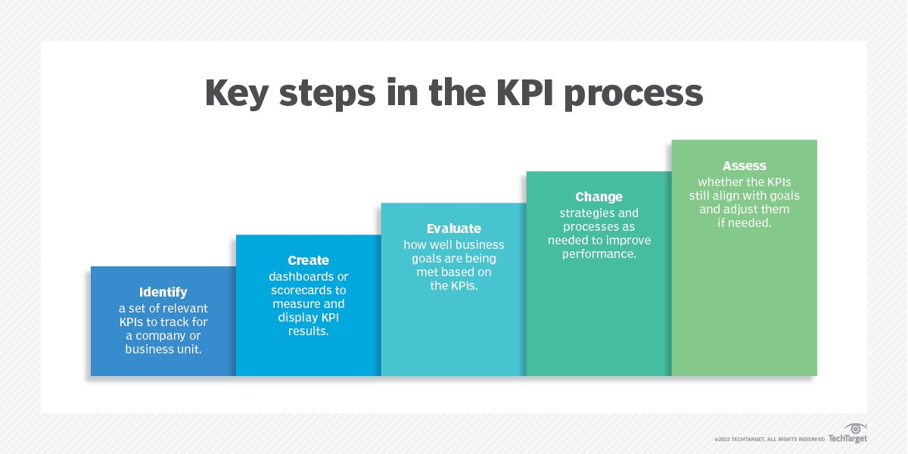Key performance indicators shine a light on how well a business is doing. Without KPIs, it would be difficult for a company's leaders to evaluate that in a meaningful way, and to then make operational changes to address performance problems. Keeping employees focused on business initiatives and tasks that are central to organisational success could also be challenging without designated KPIs to reinforce the importance and value of those activities.

**Key steps in setting and using KPIs**

In addition to highlighting business successes or issues based on measurements of current and historical performance, KPIs can point to future outcomes, giving executives early warnings on possible business problems or advance guidance on opportunities to maximise return on investment. Armed with such information, they can manage business operations more proactively, with the potential to gain competitive advantages over less data-driven rivals.

**Types of KPIs**

KPIs that measure the results of business activities, such as quarterly profit and revenue growth, are referred to as lagging indicators because they track things that have already occurred. By comparison, KPIs that herald upcoming business developments -- say, sales bookings that will generate revenue in future quarters -- are known as leading indicators.

There's also a difference between quantitative indicators that have a numerical basis and qualitative indicators that are more abstract and open to interpretation, such as assessing user experience with a product or on a website. In the case of qualitative indicators, identifying useful KPIs can be challenging; the selection of appropriate ones depends on an organization's ability to actually measure them in some way. For example, the percentage of abandoned transactions in online shopping carts might be one indicator of customer experience on a retail website.

From a functional standpoint, key performance indicators encompass a wide variety of financial, marketing, sales, customer service, manufacturing and supply chain metrics. KPIs can also be used to track performance metrics related to internal processes, such as HR and IT operations.

**How to measure KPIs**

Once key performance indicators have been identified, they should be clearly communicated to employees so all levels of the organization understand which business metrics matter the most and what constitutes successful performance against them. This could include the entire workforce on broad corporate KPIs or smaller groups of workers on ones that apply to particular departments.

In most companies, KPIs are automatically tracked via business analytics and reporting tools that collect relevant data from operational systems and create reports on the measured performance levels. Increasingly, KPI results are presented to executives on business intelligence dashboards or performance scorecards that often include charts and other data visualizations, with the ability to drill down into the performance data for further analysis. Multiple KPIs also underlie balanced scorecard frameworks that pull together sets of metrics in an effort to provide a broader view of business performance beyond operating income and other common financial measurements.

One of the challenges in setting key performance indicators is deciding how many to track to determine organizational success. Having too many KPIs may dilute the attention paid to the truly important ones. As a result, it may be more effective to limit the scope to small sets of indicators.

Managers must continually evaluate KPIs to ensure they're still relevant and aligned with priorities in business operations. If individual KPIs no longer serve a useful purpose, they need to either be refined or replaced altogether.

**Examples of key performance indicators**

Beyond revenue, expenses and profit, commonly used financial KPIs include gross and net profit margin, which measure how much money a company makes on sales of products; inventory turnover, which tracks how quickly products held in inventory are sold; cost of goods sold, a measure of the materials and labor costs incurred in making products; accounts receivable turnover, a ratio that quantifies how quickly payments on credit sales are collected from customers; and days sales outstanding, a related metric which gauges the number of days' worth of receivables that have yet to be collected.

Marketing and sales KPIs include lead conversion rate, which measures the percentage of sales leads that are successfully turned into customers; customer acquisition cost, which calculates the average cost of acquiring new customers in marketing and sales expenses; return on marketing investment, for quantifying the financial payback of marketing campaigns and programs; customer lifetime value, a prediction of the total profit a company is likely to make from sales to individual customers; and customer churn rate, a measurement of how many customers stop buying a company's products.

Key performance indicators in customer service call centers include first-call resolution rate, which tracks the percentage of incoming inquiries from customers that are addressed without the need for additional calls; cost per call, for quantifying the average cost of handling calls; call volume, which measures the total number of calls handled during a particular period; hold time, a measure of the average time customers spend on hold during calls; and call abandonment, the rate at which customers hang up while waiting on hold.

KPIs for manufacturing and supply chain operations include the percentage of defective products made by a company; manufacturing cycle time, which measures how long it takes to make products; carrying cost, which puts a value on what it costs to keep products in inventory; percentage of out-of-stock items, for tracking the number of products that aren't available in inventory when customers order them; back-order rate, a related metric quantifying the number of orders that can't be filled when they're placed; and return rate, which assesses the percentage of items that are returned.

HR departments track key performance indicators such as employee satisfaction levels and turnover rates, while the KPIs that IT managers look at include system uptime, compliance with service-level agreements, on-time project completion rates and average resolution time on help desk tickets.

Industry-specific KPIs have also been created in retail, healthcare, financial services and other markets. For example, a retailer might track things such as the average purchase value of sales transactions and sales per square foot of brick-and-mortar retail space, while a healthcare organization might measure emergency room wait times, the average length of stay in a hospital and patient readmission rates, among other metrics.

**Dashboards**

**What are dashboards?**

Dashboards are business intelligence (BI) reporting tools that aggregate and display critical metrics and key performance indicators (KPIs) in a single screen, enabling users to monitor and examine business performance at a glance. Dashboards extract and communicate high-level insights such as anomalies, issues and trends for end-users of all skill levels, before they choose to analyze data in more detail using advanced mechanisms like contextual analytics.

As a high-level reporting mechanism, dashboards ultimately provide fast ‘big picture’ answers to critical business questions and assist and benefit decision-making in several ways:

* Communicating how a business is performing according to defined targets
* Improving informational awareness for everyone
* Organizing operational data into a well managed format
* Visualizing complex relationships in a easy-to-understand way

Dashboards connect to files, APIs, and services and organise reports (metrics and dimensional views of data) into different combinations to provide end-users a full understanding of their key metrics and drivers. It displays metrics and KPIs as a tabular or cross-tabular report, or as one or more data visualisations such as charts, graphs and maps. Dashboards can also include user-defined filters, images and text, or include more than one screen tab of information.

**Types of dashboards**

The look, feel and application of a dashboard can take different forms depending on the BI platform (embedded BI or standalone solution) your business chooses to use. The use case for each type of dashboard is also dependent on the individual user’s specific role or skill-set.

Typically, dashboards fall under three distinct types:

**1. Operational Dashboard**

Operational dashboards provide end-users the ability to monitor specific day-to-day business activities, events or processes where data is constantly changing. They enable users to act on any changes they find immediately, and make short-term decisions to optimize performance. The data collected in operational dashboards is more real time, and reflective of what is occurring in the business at the moment of consumption.

**2. Strategic Dashboard**

Also called executive dashboards, this provides an ‘at-a-glance’ overview of metrics that users require to monitor business performance. Their purpose is to support decision-makers with insight into the challenges or opportunities the business may face by focusing on high level summary reports of performance and forecasting changes in those measures. They are typically built from aggregated data – time aggregations such as weekly, monthly or quarterly views – to highlight longer term trends and patterns.

**3. Analytical Dashboard**

Analytical dashboards provide end-users the ability to drill into the detail of their data and support root cause analysis. It is typically used by business analysts and line management, as they include more contextual data, comparative analysis and historical trends than other types. Analytical dashboards are useful for manually analysing changes, though insight discovery is dependent on the user’s skill level. They also support additional advanced analytical capabilities, such as automated business monitoring and augmented analytics.

**Why should you use dashboards?**

Dashboards increase data accessibility and transparency across the business and are helpful for both regular business users and advanced data analysts in monitoring operational health and gleaning high-level insights into performance, before further analysis in advanced tools.

Dashboards have broad use cases across organisations, and with the continuous evolution of embedded analytics, which has allowed dashboard reporting to be more deeply integrated into the daily workflows of the BI user, there are numerous considerations to factor in before use.

**Analytics in Business Support Function**

There are several BA and BI tools that can automate advanced data analytics functions and require few of the specialized skills or deep knowledge of the programming languages used in data science.

These tools help businesses organize and make use of the massive amounts of data that modern internet of things and enterprise cloud applications generate. These applications may be part of supply chain management, enterprise resource planning and customer relationship management applications.

Below are some business analytics tools on the market:

Dundas BI, with automated trend forecasting and a user-friendly interface;

Knime Analytics Platform, which has high-performance data pipelining and machine learning;

Qlik's QlikView with data visualization and automated data association features;

Sisense, known for its dynamic text-analysis features and data warehousing;

Splunk, which has intuitive user interface and data visualization features;

Tableau, which has advanced unstructured text analysis and natural language processing capabilities; and

Tibco Spotfire, which offers powerful, automated statistical and unstructured text analysis.

BA tools are used in many ways. For example, they can identify customers who are likely to cancel a service offering subscription. A company would first use aggregate data from enterprise applications, using a DataOps analytics platform like DataKitchen. Then it would use a BA tool to present that data to employees. The BA tool would help employees identify customers at risk of canceling and let them take steps to keep those customers.

**When choosing a business analytics tool, organizations should consider the following:**

the sources which their data comes from;

the type of the data to be analyzed; and

the usability of the tool.

A good business analytics tool is intuitive and user-friendly. It also provides a full suite of features for more advanced analytics.

**Sales and Marketing Analytics**

Sales and marketing analytics are essential to unlocking commercially relevant insights, increasing revenue and profitability, and improving brand perception. With the help of the right analytics, you can uncover new markets, new audience niches, areas for future development and much more. Let’s look at what I believe are the best and most important sales and marketing analytics that can help any business grow and succeed. This post builds on my article on the key business analytics tools, which might make good additional background reading.

**Unmet need analytics**

Business is all about meeting the needs of customers. Unmet need analytics is the process of uncovering whether there are any unmet needs around your product or service or within your market which you could meet to increase customer satisfaction and revenue. Useful tools for unmet need analytics include product reviews, qualitative surveys, focus groups and interviews. You could also use tools like Google Trends to help identify what customers are searching for.

**Market size analytics**

Market size analytics is the process of working out how large the market is for your products and services, and whether there is sufficient growth potential. The size of the market is measured in terms of volume (how many units sold), value (money spent in that market) or frequency (how often a product or service is sold). Useful data includes government data, trade association data, financial data from competitors, and customer surveys.

**Marketing and Sales Analytics**

**Demand forecasting**

Understanding demand is essential in order to remain competitive. Demand forecasting is an area of predictive analytics that seeks to estimate the quantity of a product or service your consumers are likely to buy. It goes beyond educated guesses and looks at historical sales data or current data from test markets. Analytic techniques such as time series analysis can be very useful here.

**Market trend analytics**

Every business needs to know the direction its market is heading in. Market trend analytics is a process of establishing whether a market is growing, stagnant or in decline and how fast that movement is occurring. Understanding market size is important but knowing whether that market is trending up or down is also vital. To monitor market trends you can run business experiments or scenario analysis to see what the market would look like and how it would impact your business in either a growing, stagnating or growth market. Customer surveys and focus groups can also help.

**Non-customer analytics**

Traditionally we’ve been told that we need to understand our customers so that we know what they look like and can find more people like them. And whilst that makes sense there is another group that could be even more important – the non-customer! Non-customer analytics is about understanding what people who are currently not your customers think about your product, services or brand. By identifying who is not buying from you (and why), you can expand your market to include those individuals. If you want to know why people are not buying your product or service, you need to ask them: interviews, questionnaires and focus groups can help.

**Competitor analytics**

Your business does not exist in a vacuum. Competitor analytics is important for marketing and strategic planning by identifying who your real competitors are, and how they are positioned in the market and in relation to your business. By understanding their strengths and weaknesses you can identify opportunities to exploit and threats to navigate. There are many ways of gathering competitor data, such as business journals and newspapers, annual reports, product brochures and marketing activity. You could even have an employee, friend or family member buy a product or service from your key competitors and assess their experience.

**Pricing Analytics**

What if you could find out exactly how much your customers would pay for your product ahead of time? Pricing analytics is the process that delivers that outcome. In short, it involves analysing price sensitivity in market segments and is especially useful in highly competitive markets where everything that can be done has been done. Pricing analytics requires data mining and the development of forecasting models and algorithms. It also often involves multiple, concurrent business experiments that can be run quickly and easily so you can measure what is likely to happen with each price change.

**Marketing And Sales Channel Analytics**

There are literally hundreds of possible channels and ways to market and sell your products and services. Marketing and sales channel analytics allows you to assess the different channels available to you and establish which are the most effective. It is likely you will reach different segments of your market via different channels but is it still good to know which ones are working and which are less effective. For each of your current marketing and sales channels and any potential as yet unused channels you will need to set some conversion rate goals so you know what you want that channel to deliver.

**Brand analytics**

Brands matter. Brand analytics seeks to determine the strength of your brand compared to your competitors. Your brand is more than just your logo and your commercial livery – it’s the look and feel of your products and what they represent to your customers. It’s important to really understand how customers perceive your brand as this will impact your decision making and strategic direction. You can source this sort of data anywhere your customers and potential customers are discussing your brand, such as customer service conversations, sales conversations, online forums, blogs, review sites, and social media.

**HR Analytics**

HR analytics is a data-driven method of improving decisions that impact HR functions. HR analytics depends on the quality of the data collected from HR metrics, such as:

* Time to hire
* Time to fill
* Application drop out rate
* First-year turnover rate
* Top talent retention rate
* Average absenteeism rate
* Training expense per employee
* Employee engagement
* Human capital risk

**Why should HR leaders care about HR analytics?**

Utilizing data relevant to HR strategies enables HR leaders to identify successful practices and pinpoint weak areas in need of improvement. HR analytics enables strategic decision-making that can drive business solutions through improving:

* Productivity
* Engagement
* Retention
* go to promotion

**What can HR leaders do to implement HR analytics?**

Incorporating these practices can pave a smooth path for effective integration of HR analytics:

**Create a plan.** Determine the business issues to focus on, ranking the most pressing ones first. Include a detailed breakdown of the HR functions and how to adjust them to improve the business problems.

**Identify metrics** to use that will promote results and elevate HR functions to reach long-term goals.

**Involve data scientists.** Welcoming data scientists into the process enhances HR analytics immensely. Data scientists can monitor the quality and accuracy of the data and help HR professionals implement the data to their benefit; using the information to prove a point or support a game plan is a crucial aspect of HR analytics. Furthermore, data scientists can coach and instruct employees through the nuances of the HR analytics process.

**Prepare HR personnel.** Request that HR personnel evaluates the current analytics level of the company. Once they cultivate an awareness of their standing and determine what they need to do to reach the next level, they can take steps to progress.

**Educate HR professionals.** Analytics brings an abundance of AI that challenges the status quo at work, so HR professionals must equip themselves with the knowledge to ride the oncoming tech waves. HR leaders can help HR generalists and business partners adapt to the digital transformation by facilitating their analytics education. In this way, employees can gradually acclimate to the rise of analytics in the work culture.

**Ensure legal compliance.** Explain the legal guidelines to managers, executives, and HR personnel to avoid breaching employees’ rights and privacy. It’s crucial to behave with transparency concerning the type and amount of data that the company collects. HR leaders should consult a specialist in employment law to assist them in following regulations and implementing bylaws.

**How does HR analytics improve company culture?**

HR analytics equips HR leaders with the necessary data to improve HR functions and the employee experience. With the continuous influx of tech innovations challenging the workplace, managing employees intelligently and supporting them through the demanding employee lifecycle is essential. Enhancing HR strategies through HR analytics can promote job satisfaction and lead to a healthy company culture comprised of engaged individuals.

**Financial Analytics**

**What Is Financial Analytics?**

Financial analytics is a concept that provides different views on the business’ financial data. It helps give in-depth knowledge and take strategic actions against them to improve your business’ overall performance. Financial analytics is a subset of BI & EPM and has an impact on every aspect of your business. It plays a crucial role in calculating your business’ profit. It helps you answer every business question related to your business while letting your forecast the future of your business.

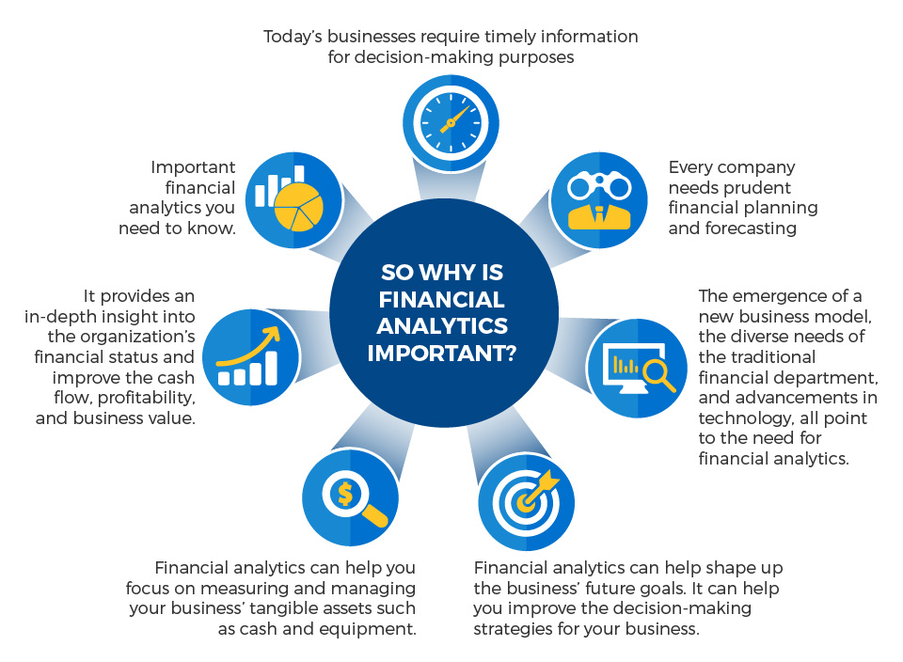

**So why is financial analytics important?**

Today’s businesses require timely information for decision-making purposes

Every company needs prudent financial planning and forecasting

The diverse needs of the traditional financial department, and advancements in technology, all point to the need for financial analytics.

Financial analytics can help shape up the business’ future goals. It can help you improve the decision-making strategies for your business.

Financial analytics can help you focus on measuring and managing your business’ tangible assets such as cash and equipment.

It provides an in-depth insight into the organization’s financial status and improves the cash flow, profitability, and business value.

**Why is financial analytics important?**

Important financial analytics you need to know

In today’s data-driven world, analytics is critical for any business that wants to remain competitive. Financial analytics can help you understand your business’ past and present performance and make strategic decisions. Here are some of the critical financial analytics that any company, size notwithstanding, should be implementing.

**1. Predictive sales analytics**

Sales revenue is critical for every business. As such, accurate sales projection has essential strategic and technical implications for the organization. A predictive sales analytics involves coming up with an informed sales forecast. There are many approaches to predicting sales, such as the use of correlation analysis or use of past trends to forecast your sales. Predictive sales analytics can help you plan and manage your business’ peaks and troughs.

**2. Client profitability analytics**

Every business needs to differentiate between clients that make them money and clients that lose them money. Customer profitability typically falls within the 80/20 rule, where 20 percent of the clients account for 80 percent of the profits, and 20 percent of the clients account for 80 percent of customer-related expenses. Understanding of which is vital.

By understanding your customers’ profitability, you will be able to analyze every client group and gains useful insight. However, the greatest challenge to customer profitability analytics comes in when you fail to analyze the client’s contribution to the organization.

**3. Product profitability analytics**

For organizations to remain competitive within an industry, organizations need to know where they are making, and losing money. Product profitability analytics can help you establish the profitability of every product rather than analyzing the business as a whole. To do this, you need to assess each product individually. Product profitability analytics can also help you establish profitability insights across the product range so you can make better decisions and protect your profit and growth over time.

**4. Cash flow analytics**

You need a certain amount of cash to run the organization on a day-to-day basis. Cash flow is the lifeblood of your business. Understanding cash flow is crucial for gauging the health of the business. Cash flow analytics involves the use of real-time indicators like the Working Capital Ratio and Cash Conversion Cycle. You can also predict cash flow using tools like regression analysis. Besides helping with cash flow management and ensuring that you have enough money for day-to-day operations, cash flow analytics can also help you support a range of business functions.

**5. Value-driven analytics**

Most organizations have a sense of where they are going to and what they are hoping to achieve. These goals can be formal and listed on a strategy map that pinpoints the business’ value drivers. These value drivers are the vital drivers that the organization needs to pull to realize its strategic goals. Value driver analytics assesses these levers to ensure that they can deliver the expected outcome.

**6. Shareholder value analytics**

The profits and losses, and their interpretation by analysts, investors, and the media can influence your business’ performance on the stock market. Shareholder value analytics calculates the value of the company by looking at the returns it is providing to shareholders. In other words, it measures the financial repercussions of a strategy and reports how much value the strategy in question is delivering to the shareholders. Shareholder value analytics is used concurrently with profit and revenue analytics. You can use tools like Economic Value Added (EVA) to measure the shareholder value analytics.Financial analytics is a valuable tool that every organization, small and large, should use to manage and measure its progress.

**Production and Operations Analytics**

**What is Operational Analytics?**

Operational analytics refers to the category of business analytics that focuses on measuring the existing and real-time operations of the business. It uses data analysis and business intelligence to improve efficiency and streamline everyday operations in real-time. With the support of data mining, artificial intelligence and machine learning, operational analytics provides businesses better transparency thereby helping them to make better decisions.

In today’s business context, it is imperative that businesses access real-time data with total transparency into customer behaviour and business processes so that the business owners can monitor their day-to-day Operations basis which they can take the necessary actions to improve customer satisfaction and bottom line.

**Benefits of Operational Analytics**

The following are the reasons why businesses are increasingly investing in operational analytics:

**1. Expedites Decision Making**

Businesses that analyse and react to customer data in real-time can make faster decisions. In the traditional way of working, Businesses would be aware of any glaring issues in their operations only based on a quarterly or annual data and by the time they make changes reactively to their operations, there is always a chance that they might not be able to attend these issues on time.

On the other hand, Businesses that embrace operational analytics, can make the necessary adjustments to processes and workflows in real-time or close to it and are therefore better equipped to increase profitability and reduce waste. This would also help them to detect and respond to problems and inefficiencies quickly.

**2. Improved Customer Experiences**

Businesses that employ operational analytics can provide improved customer experience as they can react to business situations in real-time. For eg., an Air Travel Portal which uses operational analytics finds that users are mostly using separate transactions to book onward and return journeys despite being offered a discount to book both the journeys in a single transaction. The Company which owns the Portal with the help of the operational analytics data finds that there is a bug in the software when the user selects both the journeys as a part of the single transaction causing the discount not to be offered. The bug is resolved quickly, and the Portal does not lose customers who could have possibly availed a different Travel Portal to book their tickets.

**3. Increased Productivity**

Operational analytics help businesses streamline their operations by enabling them to see inefficiencies in their processes and make the necessary changes. For example, a business based on the operational analytics data it has generated realized that the process of approving an invoice for payment is tedious and requires too many approvals which are impacting their SLAs. This data might prompt the business to rethink differently with an optimum number of approvals and streamline the process which eventually will reduce the turnaround time for the process.

**Use cases for Operational Analytics in the Business world**

**Following are some of the common operational analytics use cases:**

**1. Banks use Operational Analytics to provide suitable Products**

Banks leverage operational analytics to categorize customers based on their usage, credit risk and other parameters. This data is then used to provide suitable products to the Customer based on the category.

**2. Operational Analytics is used for Preventive Maintenance in Manufacturing**

Manufacturing companies use operational analytics to activate preventive maintenance of machines, machine parts, etc. to identify potential problems before they occur. With this data, the manufacturer can be alerted that service is required.

**3. Operational Analytics in Supply Chain Management**

For businesses which are not digitally integrated, if the Supplier is not able to deliver the goods agreed on a particular day would entail administrative efforts from all involved including Supplier, Planner, staff in charge of goods receipt, ERP system, etc. The reason for this additional manual work is the lack of proper analysis of the consumption, stock, and Supply situation. Implementation of operational analytics in Supply Chain provides employees with well-structured dashboards containing critical information which they can analyse and quickly agree with the Supplier on a supplemental delivery.

**4. Operational Analytics in Marketing**

A marketing manager or any other person well-versed in using data systems can run multiple experiments at once using operational analytics, gather results from experiments in the form of data, terminate the ineffective experiments and nurture the ones that work, all using data-based software systems. The more experiments they can run and the quicker the turnaround times of results, the better their effectiveness in marketing their product.

**5. Operational Analytics helping Product Manager make a product better**

A product manager looks at product-usage logs provided by operational analytics to determine which features of the product are liked by its users, which features slow them down, and which features are disliked by its users. The product manager can then find the necessary answers by querying data that records usage patterns from the product’s user base and feed this information back to make the product better.

**Analytics in Industries**

Business analytics uses sorting, collating, processing, and studying data through iterative methodologies and statistical models to generate meaningful and business-relevant insights. These insights help organisations in solving business problems and increase their revenue, efficiency, and productivity.

Business analytics helps companies make better-informed decisions regarding their finances, daily operations, and many other aspects of their organisation. It’s a highly versatile domain and finds applications in multiple industries.

**1. Energy and Fuel**

The energy and fuel sector uses business analytics in multiple aspects of its operations. As these companies deal internationally, the severity of their problems is also very high. Implementation of business analytics allows them to mitigate the risks and reduce the chances of facing any prominent issues.

Business analytics focuses on using data to find insights that an organisation can use to make better-informed decisions. Through its use, they can optimise the transportation of their products and pricing.

Royal Dutch Shell, a prominent energy company and the world’s fourth-largest company by revenue in 2015, has started using analytics to create ‘data-driven oilfields’ to reduce the costs of drilling for oil – the largest expenses for an oil company.

**2. Agriculture**

Contrary to popular belief, there are many advanced technologies and methods such as big data and business analytics in agriculture. Farmers can use business analytics to understand which factors influence their crops’ growth and accordingly prepare for the next season.

Business analytics and data science can help farmers manage their tools and machines while optimising their performance depending on their requirements and generated data.

A prominent US agricultural company, John Deere, has started offering many data-based services to their farmers to help them make better-informed decisions and enhance their agricultural progress.

Companies and buyers of these crops also employ business analytics to optimise their warehousing, storage, and transportation of raw materials.

**3. Government and Public Sector**

Governments all across the world have started using business analytics and data to enhance their operations. For example, the central government has established the CEDA (Centre of Excellence for Data Analytics) to help government organisations to generate insights for their data.

CEDA helps government organisations define their analytic requirements, build the required analytics solutions, integrate departmental data silos and process big data as per the department’s requirements.

CEDA also focuses on using machine learning algorithms for advanced data analytics. Through implementing business analytics, government agencies and organisations can find areas for improvement and make the necessary changes accordingly.

**4. Finance**

Out of all the industries we have shared in this article, the finance sector is probably the biggest business analytics user. There are numerous applications of business analytics and big data in the finance industry. Business analytics helps finance companies in evaluating potential investments and determine their risk/reward.

Credit card companies generate and gather a ton of data from their customers, such as their financial health, buying preferences, and lifestyle choices. They share this data with their business partners enabling them to create better deals and discount offers to enhance profits.

For example, a credit card company might share such data with retailers, helping them locate their target audience and predict what their customers prefer buying. Then the retailers can leverage this information to devise more accurate marketing strategies.

**5. Education**

The education sector has started using a lot of technology recently. The pandemic further fueled the need for more technological implementation in this industry as the demand for online learning solutions rose rapidly.

Education companies use business analytics to optimise their courseware and learning methodologies. Business analytics helps them generate valuable insights to improve their teaching methods and enhance their learning experiences.

Large schools and colleges have started leveraging business analytics to optimise bus routes and improve enterprise management (inventory management, decision-making, etc.).

**6. Entertainment and Media**

Netflix, Amazon Prime, and many other streaming platforms use business analytics and big data to optimise user experiences. They gather data from their millions of users and analyse it to personalise their recommendations and make their user’s interaction with the platform more enjoyable.

A user’s chosen genres, watch history, and other related data help enhance their recommendation systems. For example, a prominent music-streaming platform, Spotify, suggests songs and playlists according to the songs, albums, genres, and artists a user has listened to or interacted with.

**7. Retail Trading**

The most notable use of business analytics in the retail sector is E-commerce. Major E-commerce companies, such as Amazon, employ business analytics to personalise user recommendations and, as a result, enhance their sales.

Personalised recommendations help in increasing sales as users find the products they need much easily and quickly. Apart from personalisation, business analytics helps retail companies understand which products sell the highest and why they should optimise other products accordingly. For example, a particular product might be selling more because of its placement in the store, so they can switch their location with another product that might be selling less.

**8. Logistics**

Business analytics has many applications in business’ logistics. A prominent branch of business analytics is supply chain analytics, where they analyse the organisation’s supply chain (warehousing, logistics, transport, etc.) and find the weak areas in the same.

Businesses use business analytics to identify techniques that can improve their transportation methods to be more efficient and effective. A more effective transportation solution will help the company save a lot of time and resources in transporting raw materials, finished goods, and manufacturing components.

Supply chain analytics also helps a business reduce storage and warehousing costs by finding better alternatives and solutions. It allows them to identify arising problems in the logistics so they can nip them in the bud.

**9. Marketing**

Apart from finance, another industry that uses business analytics extensively is marketing. Organisations use business analytics to test out different marketing methods and find the one which offers optimal results. It helps them identify the marketing implementations with the highest ROI (Return on Investment), which allows them to make future promotion plans accordingly.

For example, A/B testing is a prevalent analytics implementation where a company uses two versions of a landing page (or another promotional aspect) and sees which one performs better. Then, the company would remove the landing page that performed poorly and only uses the one which offered the best results.

**10. Human Resources**

Human resources professionals, such as HR managers and talent acquisition specialists, use business analytics to enhance their recruitment processes. HR companies have numerous candidates and clients. Through data analytics, they can go through their candidates’ profiles quickly and efficiently.

Apart from HR companies, HR professionals in other industries use business analytics to predict and improve their employee retention rate and make decisions accordingly. Business analytics helps companies in making major HR-related decisions regarding payroll, recruitment, etc.

**11. Transport**

The transport and travel industry uses business analytics in many areas. First, governments employ business analytics to monitor and control traffic. It helps them in optimising route planning and develop intelligent transport systems to manage the general traffic effectively. As governments start implementing more technologies, the demand for business analytics in traffic management will increase further.

On the other hand, travel companies use business analytics to create customer profiles and find ways to optimise their user experiences.

For example, a travel agency might use business analytics to figure out why a specific tourism package fails to generate sales through surveys and customer feedback and optimise the same.

**Decision making under Uncertainty example problems**

A decision problem, where a decision-maker is aware of various possible states of nature but has insufficient information to assign any probabilities of occurrence to them, is termed as decision-making under uncertainty. A decision under uncertainty is when there are many unknowns and no possibility of knowing what could occur in the future to alter the outcome of a decision.

We feel uncertainty about a situation when we can't predict with complete confidence what the outcomes of our actions will be. We experience uncertainty about a specific question when we can't give a single answer with complete confidence.

Launching a new product, a major change in marketing strategy or opening your first branch could be influenced by such factors as the reaction of competitors, new competitors, technological changes, changes in customer demand, economic shifts, government legislation and a host of conditions beyond your control. These are the type of decisions facing the senior executives of large corporations who must commit huge resources.

The small business manager faces, relatively, the same type of conditions which could cause decisions that result in a disaster from which he or she may not be able to recover.

A situation of uncertainty arises when there can be more than one possible consequences of selecting any course of action. In terms of the payoff matrix, if the decision-maker selects A1, his payoff can be X11, X12, X13, etc., depending upon which state of nature S1, S2, S3, etc., is going to occur.

**Methods of Decision Making under Uncertainty**

The methods of decission making under certainity are.There are a variety of criteria that have been proposed for the selection of an optimal course of action under the environment of uncertainty. Each of these criteria make an assumption about the attitude of the decision-maker.

Maximin Criterion: This criterion, also known as the criterion of pessimism, is used when the decision-maker is pessimistic about future. Maximin implies the maximisation of minimum payoff. The pessimistic decision-maker locates the minimum payoff for each possible course of action. The maximum of these minimum payoffs is identified and the corresponding course of action is selected. This is explained in the following example :

Example : Let there be a situation in which a decision-maker has three possible alternatives A1, A2 and A3, where the outcome of each of them can be affected by the occurrence of any one of the four possible events S1, S2, S3 and S4. The monetary payoffs of each combination of Ai and Sj are given in the following table:

monetary payoffs of each combination of Ai and Sj

Solution: Since 17 is maximum out of the minimum payoffs, the optimal action is A2.

Maximax Criterion: This criterion, also known as the criterion of optimism, is used when the decision-maker is optimistic about future. Maximax implies the maximisation of maximum payoff. The optimistic decision-maker locates the maximum payoff for each possible course of action. The maximum of these payoffs is identified and the corresponding course of action is selected. The optimal course of action in the above example, based on this criterion, is A3.

Regret Criterion: This criterion focuses upon the regret that the decision-maker might have from selecting a particular course of action. Regret is defined as the difference between the best payoff we could have realised, had we known which state of nature was going to occur and the realised payoff. This difference, which measures the magnitude of the loss incurred by not selecting the best alternative, is also known as opportunity loss or the opportunity cost.

From the payoff matrix (given in § 12.6), the payoffs corresponding to the actions A1, A2, ...... An under the state of nature Sj are X1i, X2j, ...... Xnj respectively. Of these assume that X2j is maximum. Then the regret in selecting Ai, to be denoted by Rij is given by X2j - Xij, i = 1 to m. We note that the regret in selecting A2 is zero. The regrets for various actions under different states of nature can also be computed in a similar way.

The regret criterion is based upon the minimax principle, i.e., the decision-maker tries to minimise the maximum regret. Thus, the decision-maker selects the maximum regret for each of the actions and out of these the action which corresponds to the minimum regret is regarded as optimal. The regret matrix of example can be written as given below:

regret matrix

From the maximum regret column, we find that the regret corresponding to the course of action is A3 is minimum. Hence, A3 is optimal.

Hurwicz Criterion: The maximax and the maximin criteria, discussed above, assumes that the decision-maker is either optimistic or pessimistic. A more realistic approach would, however, be to take into account the degree or index of optimism or pessimism of the decision-maker in the process of decision-making. If a, a constant lying between 0 and 1, denotes the degree of optimism, then the degree of pessimism will be 1 - a. Then a weighted average of the maximum and minimum payoffs of an action, with a and 1 - a as respective weights, is computed. The action with highest average is regarded as optimal.

We note that a nearer to unity indicates that the decision-maker is optimistic while a value nearer to zero indicates that he is pessimistic. If a = 0.5, the decision maker is said to be neutralist.

We apply this criterion to the payoff matrix of example 17. Assume that the index of optimism a = 0.7.

criterion to the payoff matrix

Since the average for A3 is maximum, it is optimal.

Laplace Criterion: In the absence of any knowledge about the probabilities of occurrence of various states of nature, one possible way out is to assume that all of them are equally likely to occur. Thus, if there are n states of nature, each can be assigned a probability of occurrence = 1/n. Using these probabilities, we compute the expected payoff for each course of action and the action with maximum expected value is regarded as optimal.

**Case study: prepare a detailed report on applications of analytics in different industries.**

**1. Transportation**

Data analytics can be applied to help in improving Transportation Systems and the intelligence around them. The predictive method of the analysis helps find transport problems like Traffic or network congestion. It helps synchronize the vast amount of data and uses them to build and design plans and strategies to plan alternative routes and reduce congestion and traffic, which in turn reduces the number of accidents and mishappenings. Data Analytics can also help to optimize the buyer’s experience in the travels by recording the information from social media. It also helps travel companies fix their packages and boost the personalized travel experience as per the data collected.

For Example During the Wedding season or the Holiday season, the transport facilities are prepared to accommodate the heavy number of passengers travelling from one place to another using prediction tools and techniques.

**2. Logistics and Delivery**

There are different logistic companies like DHL, FedEx, etc that use data analytics to manage their overall operations. Using the applications of data analytics, they can figure out the best shipping routes, and approximate delivery times, and also can track the real-time status of goods that are dispatched using GPS trackers. Data Analytics has made online shopping easier and more demandable.

Example of Use of data analytics in Logistics and Delivery:

When a shipment is dispatched from its origin, till it reaches its buyers, every position is tracked which leads to the minimizing of the loss of the goods.

**3. Web Search or Internet Web Results**

The web search engines like Yahoo, Bing, Duckduckgo, and Google use a set of data to give you when you search a data. Whenever you hit on the search button, the search engines use algorithms of data analytics to deliver the best-searched results within a limited time frame. The set of data that appears whenever we search for any information is obtained through data analytics.

The searched data is considered as a keyword and all the related pieces of information are presented in a sorted manner that one can easily understand. For example, when you search for a product on amazon it keeps showing on your social media profiles or to provide you with the details of the product to convince you by that product.

**4. Manufacturing**

Data analytics helps the manufacturing industries maintain their overall work through certain tools like prediction analysis, regression analysis, budgeting, etc. The unit can figure out the number of products needed to be manufactured according to the data collected and analyzed from the demand samples and likewise in many other operations increasing the operating capacity as well as the profitability.

**5. Security**

Data analyst provides utmost security to the organization, Security Analytics is a way to deal with online protection zeroed in on the examination of information to deliver proactive safety efforts. No business can foresee the future, particularly where security dangers are concerned, yet by sending security investigation apparatuses that can dissect security occasions it is conceivable to identify danger before it gets an opportunity to affect your framework and main concern.

**6. Education**

Data analytics applications in education are the most needed data analyst in the current scenario. It is mostly used in adaptive learning, new innovations, adaptive content, etc. Is the estimation, assortment, investigation, and detailing of information about students and their specific circumstances, for reasons for comprehension and streamlining learning and conditions in which it happens.

**7. Healthcare**

Applications of data analytics in healthcare can be utilized to channel enormous measures of information in seconds to discover treatment choices or answers for various illnesses. This won’t just give precise arrangements dependent on recorded data yet may likewise give accurate answers for exceptional worries for specific patients.

**8. Military**

Military applications of data analytics bring together an assortment of specialized and application-situated use cases. It empowers chiefs and technologists to make associations between information investigation and such fields as augmented reality and psychological science that are driving military associations around the globe forward.

**9. Insurance**

There is a lot of data analysis taking place during the insurance process. Several data, such as actuarial data and claims data, help insurance companies realize the risk involved in insuring the person. Analytical software can be used to identify risky claims and bring them before the authorities for further investigation.

**10. Digital Advertisement**

Digital advertising has also been transformed as a result of the application of data science. Data analytics and data algorithms are used in a wide range of advertising mediums, including digital billboards in cities and banners on websites.

**11. Fraud and Risk Detection**

Detecting fraud may have been the first application of data analytics. They applied data analytics because they already had a large amount of customer data at their disposal. Data analysis was used to examine recent spending patterns and customer profiles to determine the likelihood of default. It eventually resulted in a reduction in fraud and risk.

**12. Travel**

Data analysis applications can be used to improve the traveller’s purchasing experience by analyzing social media and mobile/weblog data. Companies can use data on recent browse-to-buy conversion rates to create customized offers and packages that take into account the preferences and desires of their customers.

**13. Communication, Media, and Entertainment**

When it comes to creating content for different target audiences, recommending content, and measuring content performance, organizations in this industry analyze customer data and behavioural data simultaneously. Data analytics is applied to collect and utilize customer insights and understand their pattern of social-media usage.

**14. Energy and Utility**

Many firms involved in energy management use data analysis applications in areas such as smart-grid management, energy distribution, energy optimization, and automation building for other utility-based firms.

**APPLICATIONS OF DATA ANALYTICS IN THE BUSINESS WORLD**

The use of data analytics in business is not confined internally, Business Analysts direct market examinations, dissecting both product offerings and the general productivity of the business. Furthermore, they create and screen information quality measurements and guarantee business information and detailing needs are met. Business Analysts direct market examinations, dissecting both product offerings and the general productivity of the business. Furthermore, they create and screen information quality measurements and guarantee business information and detailing needs are met.

**PART-A**

1. What is business performance management?

2. List the stages of performance management cycle.

3. What are the SMART goals?

4. Define KPI?

5. What are dashboards?

6. Write the types of dashboards

7. State HR Analytics

8. Why should HR leaders care about HR analytics

9. What is Financial Analytics?

10. List the benefits of Operational Analytics.

**PART-B**

1. Explain Performance Management Cycle stages?

2. Write about Analytics in Business Support function in detail.

3. Give a brief about Marketing Sales Analytics.

4. Describe about Key Performance Indicator with an example?

5. Explain in detail about Dashboards and its types.

6. Illustrate Operational Analytics with its use cases.